26-2-10 Market Rewards: Following Structure, Not Prediction
[IMAGE] /home/ubuntu/upload/pasted_file_hwfANI_image.webp ## 1 BTC 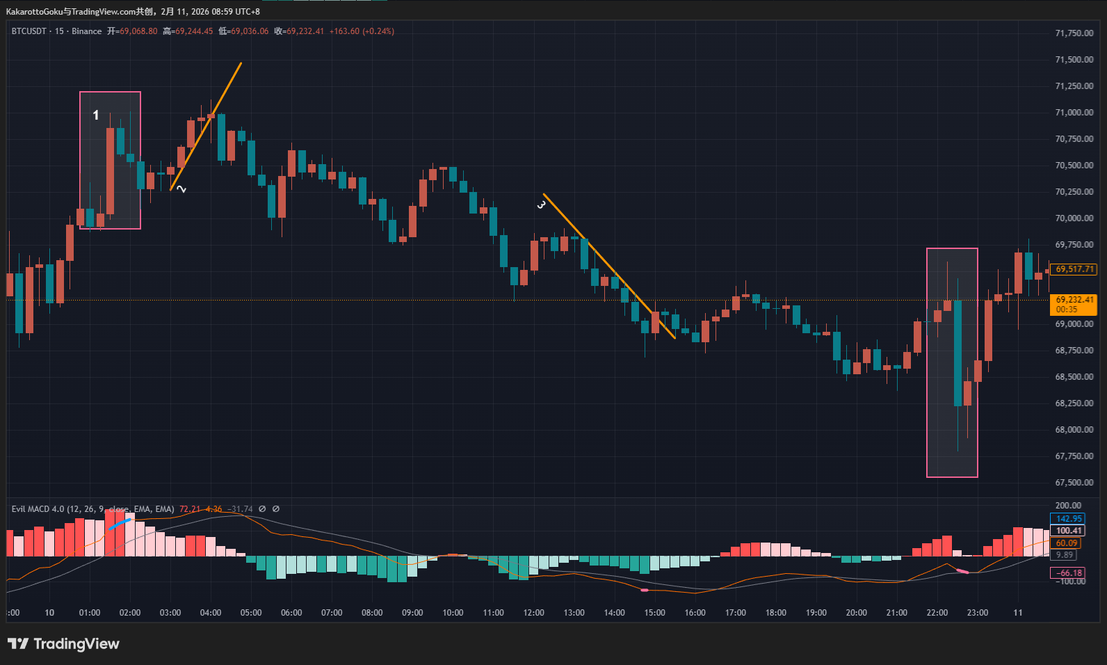 First, at point 1, we can see a blue-line top warning. However, a closer look shows that due to the impact of a large bullish candle in this area, it is impossible to draw a valid trendline. Without a valid trendline, trendline-based analysis does not apply.
In addition, this kind of sudden expansion in candle body usually represents a sharp increase in strength from one side of the market, which introduces a high level of uncertainty. For this reason, it is best to stay away from such situations.
Later, trendline 2 is formed. This is a trendline that has been tested and confirmed by the market, and it is broken to the downside by a clear bearish candle. This becomes a higher-probability transition point from bullish to bearish.
It is important to note that the two doji candles before the break do not have a negative impact here. Generally speaking, if the breakout candle itself is a doji, or if the breakout is weak and followed by doji candles, the setup should be avoided. In this case, however, the situation is completely different.
The two doji candles represent disagreement and active negotiation between buyers and sellers. After that, a decisive bearish candle appears, with a strong body and almost no wicks. This indicates that after the struggle, sellers clearly won and chose a definite direction. The subsequent bullish retracement candle is only about half the size of the breakout bearish candle, further confirming that bearish market consensus is dominant at this point.
This clearly shows how much profit potential the market can offer when we choose to follow price at the correct point of market consensus.
After that, a new pink thick-line bottom warning appears, indicating a potential bottom. Price then forms a new trendline, labeled trendline 3. However, when we examine the breakout, although the candle body has some strength and is not a doji-type indecision candle, the closing price does not break clearly above the trendline. Instead, it only marginally exceeds it.
Compared with the breakout of trendline 2, it is obvious that the reversal strength here is limited and lacks conviction. This suggests that the bullish side does not hold a strong advantage at this location.
Later, another pink thick-line bottom warning appears. However, due to the influence of a suddenly enlarged bearish candle, no valid trendline can be drawn. Since trendline analysis cannot be applied here, this potential reversal should also be ignored.

2 ETH
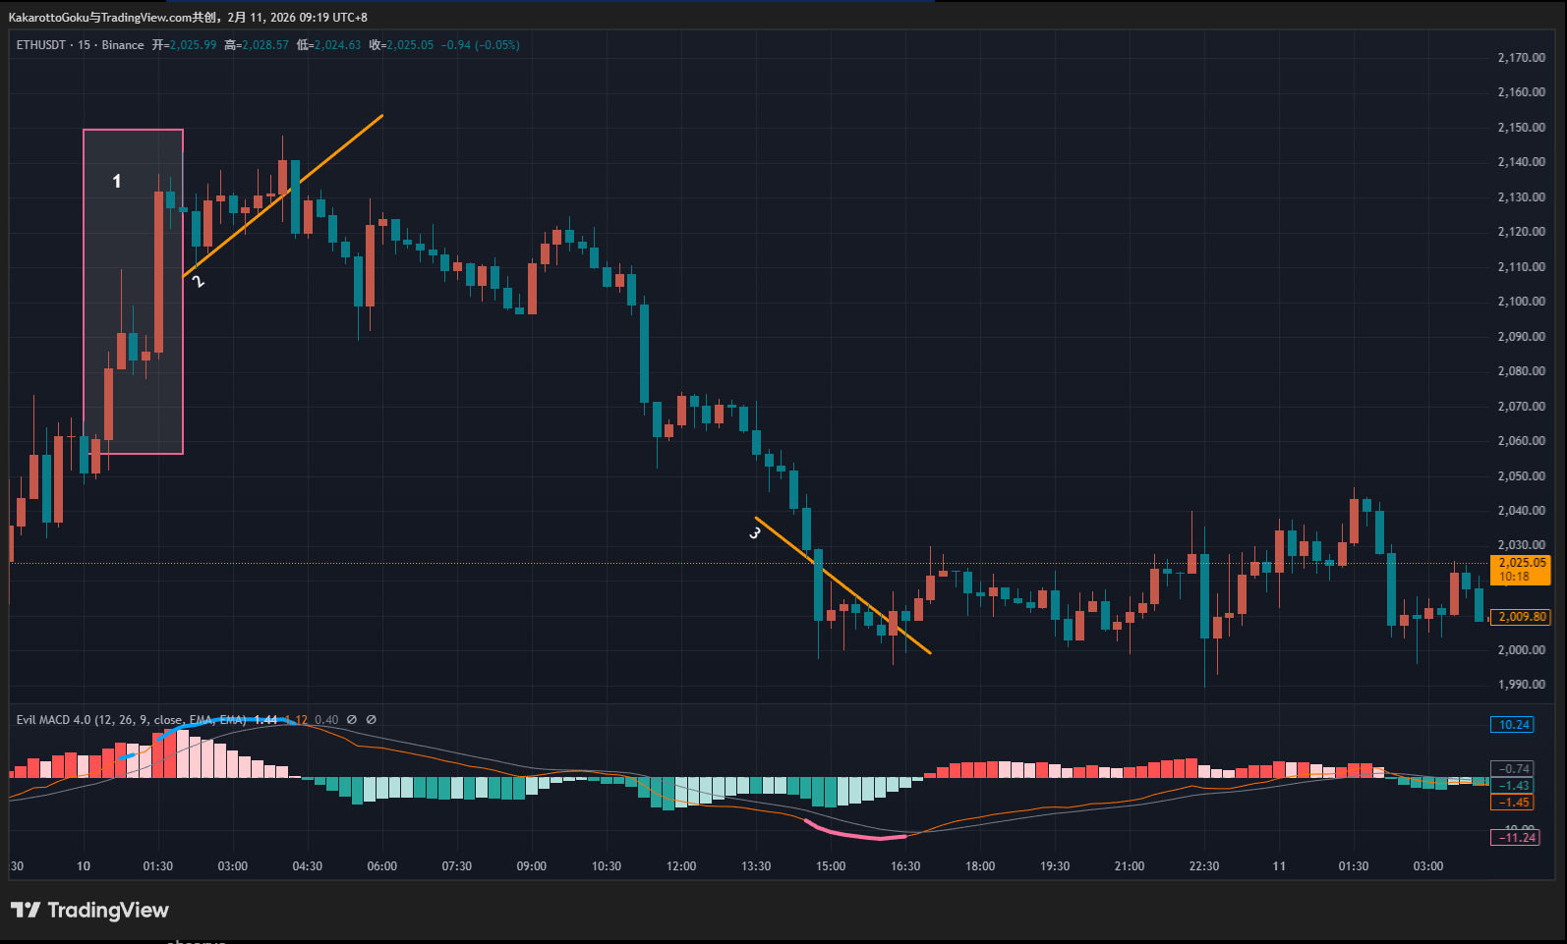 ETH develops in a similar way to BTC, but with some differences in detail.
First, we again see a blue-line top warning, indicating a potential bearish reversal. At area 1, a sudden large bullish candle appears, making it difficult to draw a valid trendline. We continue to observe.
Soon after, a market-tested trendline 2 is formed. Several indecision candles appear near the top, and after this period of negotiation, a decisive bearish candle breaks the trendline to the downside. This becomes a relatively high-probability bearish market consensus point.
Again, we can see that when we choose the correct market consensus point, the market is capable of delivering substantial profit potential.
In contrast, trendline 3 presents a very different situation.
Later, another pink thick-line bottom warning appears, indicating a potential bottom, and a new trendline 3 is formed. When this trendline is broken, the bullish candle shows a noticeable body, but the upper and lower wicks are even more prominent. The combined wick length is clearly greater than the candle body.
This type of candle represents intense buyer–seller conflict. If we only look at this breakout in isolation, it may seem confusing. However, once we compare it with the breakout of trendline 2, the difference becomes very clear: what a clean, high-probability breakout looks like, and what a breakout still dominated by indecision and conflict looks like.
By comparing reversals at points 2 and 3, we can see that choosing the right location leads to completely different profit potential afterward. In real trading systems, this directly translates into a major difference in risk-reward ratio.

3 Gold
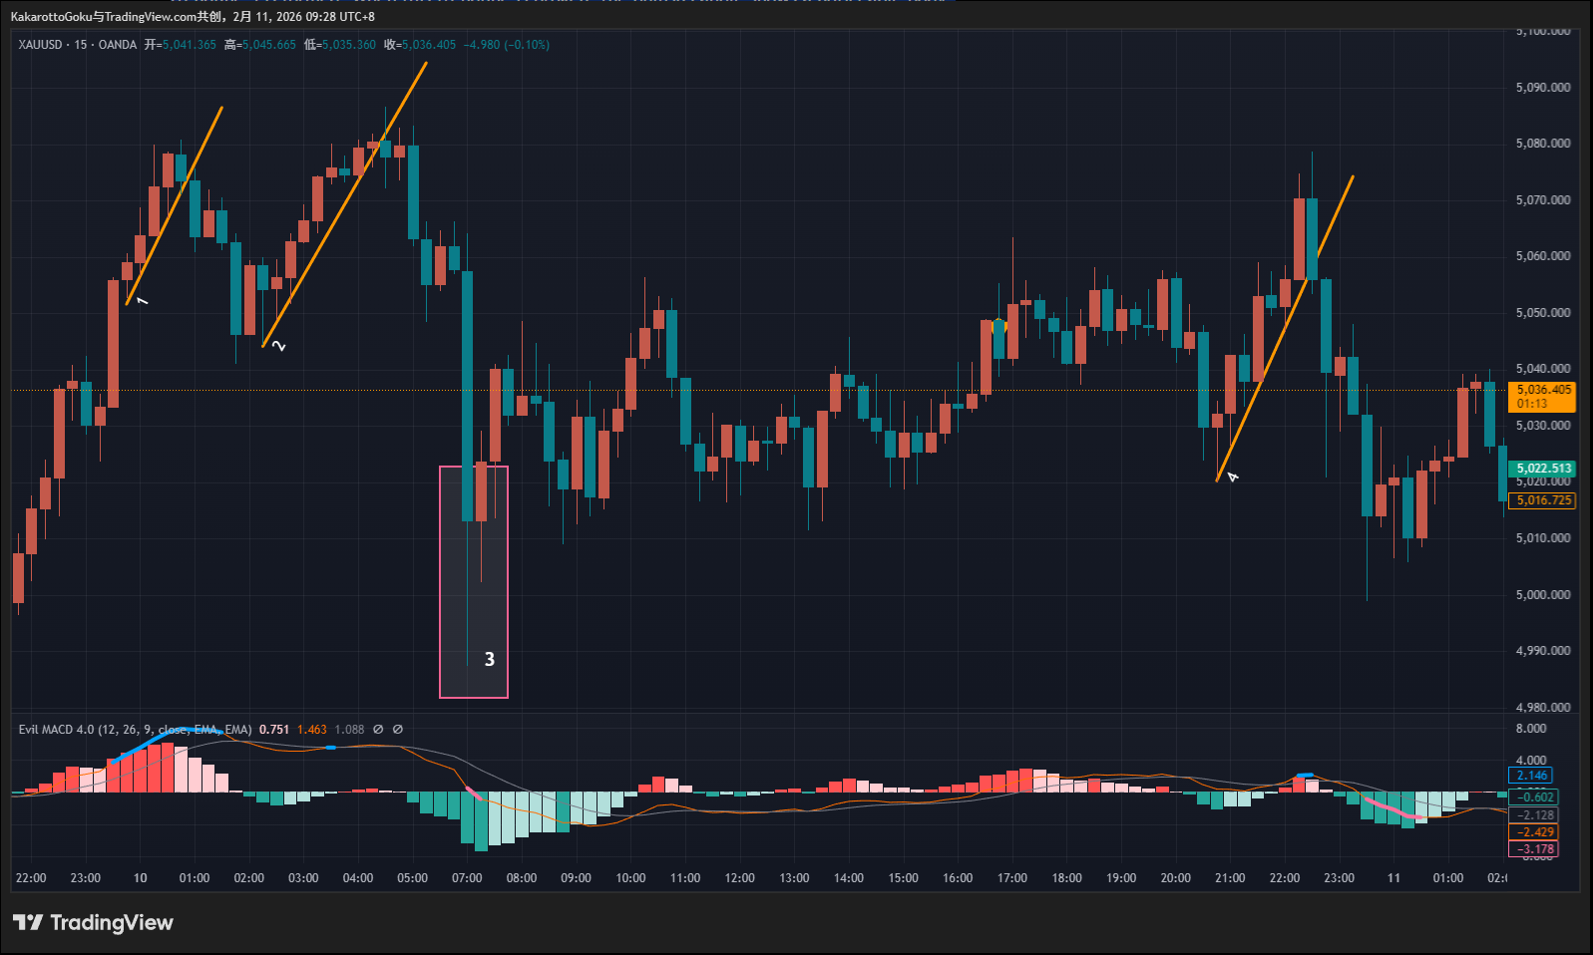 First, a blue-line top warning appears, indicating a potential bearish reversal. A clear trendline 1 is formed and is broken to the downside by a bearish candle with a solid body. This structure is very standard and can be considered a textbook model, so it does not require much explanation.
Price then pulls back upward and produces another blue-line warning. A new trendline 2 is formed, and after two doji candles showing buyer–seller negotiation near the top, price is again broken downward by a bearish candle. This is another textbook example.
Later, a pink thick-line bottom warning appears, marked as point 3 on the chart. However, due to a suddenly enlarged bearish candle, no valid trendline can be drawn. As a result, trendline analysis cannot be used to identify a valid entry here, and this reversal opportunity should be abandoned.
Finally, another blue top warning appears, and a clear trendline 4 is formed. Although the breakout candle is bearish with a visible body, its closing price lands right on the trendline, making the breakout weak rather than decisive. The following candle suddenly expands and contains a long lower wick, which makes it unsuitable as an entry point. Therefore, this setup should also be avoided.
It is important to note that this analysis is strictly based on the current timeframe. If we move down to a lower timeframe, new trendlines and better breakout points may appear. This is one way to search for optimal entries. However, it must be emphasized that traders should analyze and trade within the same timeframe. Mixing multiple timeframes too freely often leads to over-complication and interferes with sound decision-making.

Summary
We should note that although the breakouts at points 1 and 2 in gold look very similar structurally, the profit potential provided by the market afterward is completely different.
This is exactly what I keep emphasizing: the future path of the market is never predictable. Even if we choose a correct entry point, price may reverse at any moment, creating floating losses, or it may suddenly expand and generate significant unrealized profits. All of this is unknown.
What we can do is simply follow the market at the correct entry points. As for how far price will go, that inevitably involves a certain degree of luck. This is the correct mindset required when using any trading system. Setting rigid expectations such as “how much profit I must make” or “how many times I must multiply my capital” only leads to psychological pressure, mistakes, and distorted decision-making.
The red and blue lines mentioned in this article are used solely to mark structural positions on the chart. They do not constitute trading advice and do not represent any specific indicator or tool.

